Logo%20Main%20200

**Boston University**

**Electrical & Computer Engineering**

**EC463 Capstone Senior Design Project**

**Problem Definition and Requirements Review**

Efficient Solar Hot Water



Submitted to:

Professor Robert Kotiuga

8 St. Mary’s St Boston, MA

02215, Room 523

(617)-353-4151

prk@bu.edu

by

Team 21

Team Solar Panels

Team Members

Hal Levin [hlevin3@bu.edu](mailto:hlevin3@bu.edu)

Moises Bensadon [moises@bu.edu](mailto:moises@bu.edu)

Stanley Nguyen [stanguye@bu.edu](mailto:stanguye@bu.edu)

Yuri Zhang [zyuri@bu.edu](mailto:zyuri@bu.edu)

Submitted: October 14, 2022

**Customer Sign-Off _______________________________________**

#### Efficient Solar Hot Water

#### Table of Contents

Project Summary 2

1 Need for this Project 3

2 Problem Statement and Deliverables 4

3 Visualization 5

4 Competing Technologies 6

5 Engineering Requirements 7

6 Appendix A References. 8

(Right click on Table of Contents to update fields and page numbers automatically)

# Project Summary

As a team, we will be designing a smart, efficient, and low-maintenance solar panel hot water heating system. By adding a cooling process with water to existing solar panels, we can extend the cell’s life and efficiency. Our system would be built and implemented with residential household electrical and piping systems. A smart monitoring system will be designed in such a way that it would be flexible and sufficient for a majority of houses. This will be a heavy build project; requiring a mixture of electrical and plumbing skill sets to achieve a successful renewable energy system. The nature of the project will require modifications and/or changes to current or future designs in homes. Materials and processes such as choosing and purchasing solar panels will be necessary. For practical implementation, residential building assessments would be needed for optimal sun exposure and precise planning for solar hot water integrations.

# Need for this Project

Current solar panels are around 15%-22% efficient when operated under optimal conditions. At very hot temperatures, the efficiency and power output of the solar cells can decrease by a reasonable amount. Our client, Professor Kotiuga from Boston University, proposed an efficient improvement to current solar systems used in commercial and residential buildings. The inspiration behind Professor Kotigua’s idea is that solar panels can increase power production if they’re cooled down to an ideal temperature. Our client will be working with us in the design and manufacturing of a new solar panel system that would integrate water cooling into the system with the feature of being able to use heated water as per usual in current buildings.

With current climate change and rising temperatures, any improvement in the efficiency of energy generation is crucial and beneficial. Solar panels have been decreasing in price in the last couple of years but their efficiency hasn’t reached the levels of powering an entire home. Cooling solar panels can be a simple concept, but how can we do so in the most efficient way possible and create the least amount of waste? Something that is used regularly in typical households is water from pipelines. This water comes in cold from the outside. We will need to engineer a way of efficiently circulating water through the panels and eventually back to water heaters already present in a home.

# Problem Statement and Deliverables

Our goal is to increase solar panels' efficiency by using the cold water pumped out of water tanks or from a separate pipeline. A few crucial parts of the design we will have to look out for include pipe diameter, water pump flow rate, and materials that have a high heat transfer coefficient. We will begin by analyzing an array of solar panels and tracking cell temperature vs. power production to determine what the ideal temperature for power efficiency would be. Once determined, our team will construct a water cooling system to allow cold water to flow through the solar panel thereby decreasing the temperature of the panel and increasing photovoltaic cell efficiency. The cold water will ideally come from the exit tube of the home’s water heater since this already exists in most homes and wouldn’t require additional power dedicated to cooling the water.

All of this system also has to be designed in a way that is appealing to users and therefore we plan on creating an intuitive user dashboard for customers to view power production on a given day and the estimated increase in efficiency due to the cooling system. A possible reach goal that we could go for is implementing a system that would decide if it is more efficient to use the extra power gained to (a) power the water heater, (b) store it in batteries for future use, or (c) sell the energy back to the city grid. The reason behind these choices would be based on the time of year, the fact that batteries lose charge over time, and the price the city pays for electricity buybacks.

# Visualization

*Figure 3.1: The working process of the hybrid solar system and the side view of the solar panel and cooling/warming panel*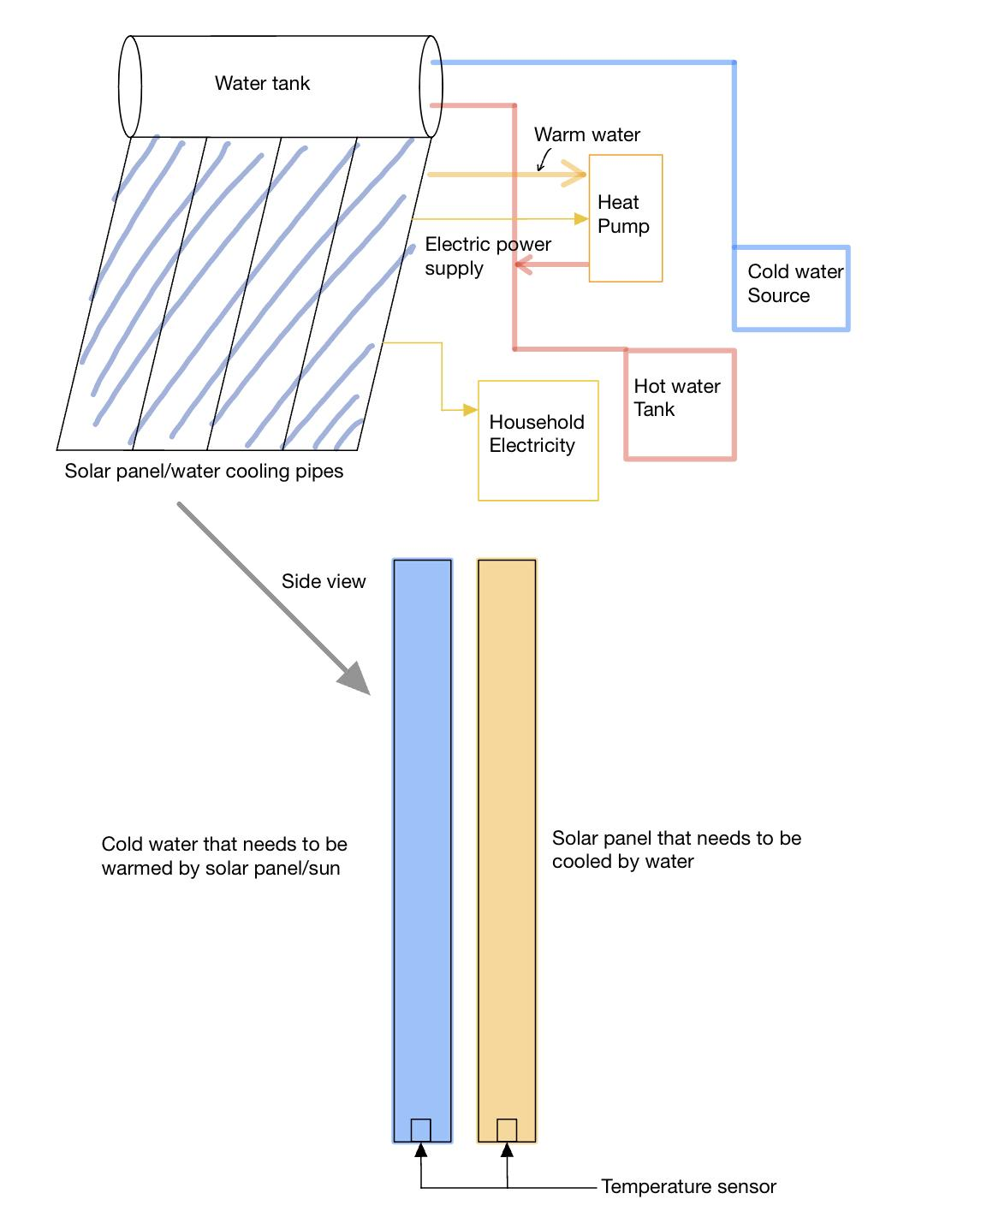

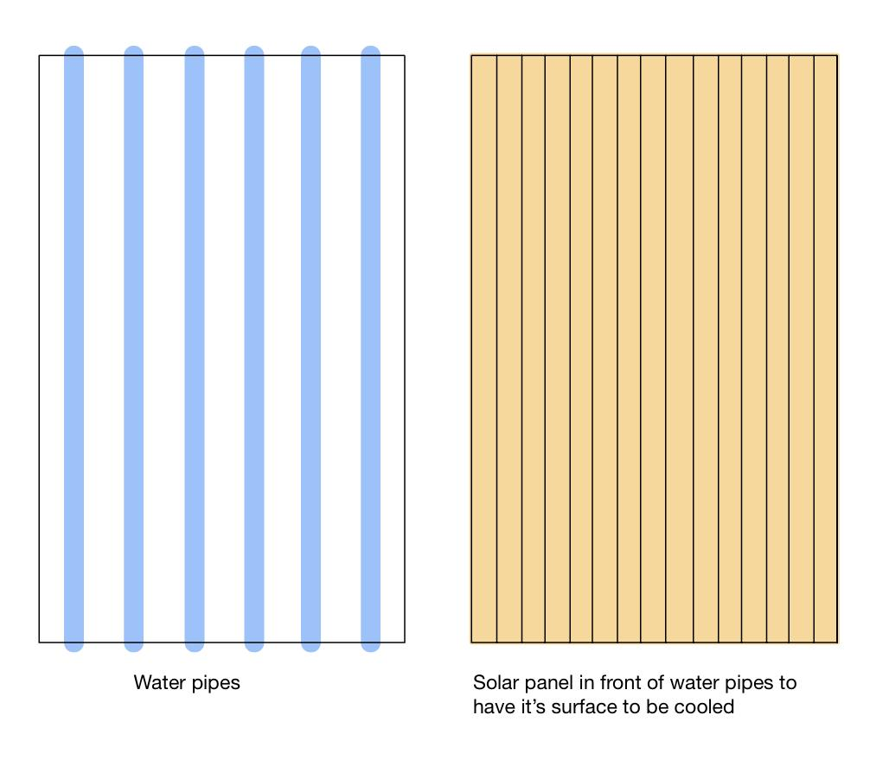

*Figure 3.2: Schematic diagram of the separated cooling/warming panel and solar panels*

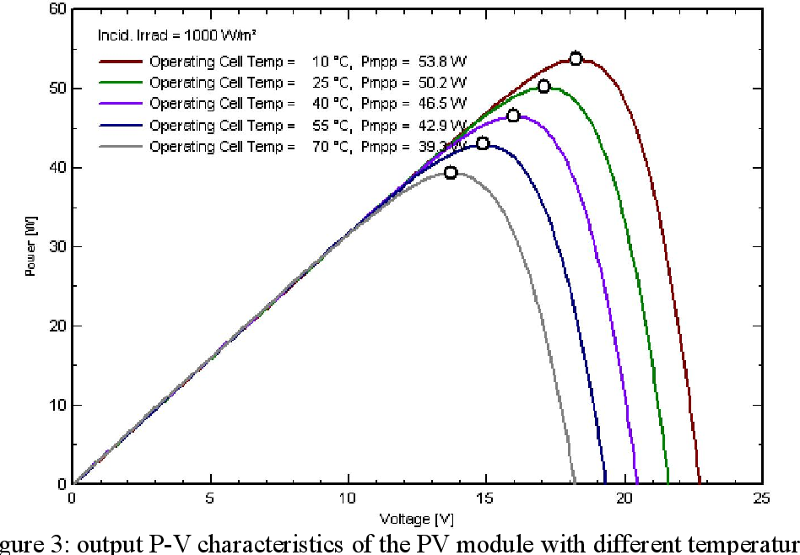

*Figure 3.3: Solar panels need to be at the right temperature to output maximum power for the same input.*

# Competing Technologies

Some of the tech companies competing alongside us are: Everything Solar®; RevoluSun®; and DualSun®.

Among them, Everything Solar® and RevoluSun® are mainly selling solar water heaters. Traditional solar water heaters are not our main competing technology, but to some extent, we all use solar energy to heat water to reduce the energy waste of electric water heaters.

SPRING®-Hybrid solar panel designed by DualSun® is very similar to our design philosophy. DualSun® is a European-based technology company whose main products are hybrid solar panels and solar water heaters like ours. However, DualSun®'s technology is out of reach for the Americas, where they have neither agents nor direct sales channels.

In the SPRING®-Hybrid solar panel designed by DualSun®, they placed the solar panel at the front end and added a heat exchanger at the back end of the solar panel, through which the heat generated by the solar panel is transferred to the water. This enables more efficient production of electrical energy and simultaneous production of hot water.

While doing all this, their designs don't take up much extra space than regular solar panels, thanks to their highly integrated heat exchangers. At the same time, they don't seem to have a tank to store excess cold water. This also enhances the compactness of their products.

# Engineering Requirements

We need to ensure that solar panels will no longer reach temperatures where efficiency will begin to drop and become less efficient. We will have the extra heat generated by the solar panels will heat our cooling water, which will be used as domestic hot water, reducing the energy that would have been used to heat water that is much colder.

A sufficient water pump will also be required for adequate water flow and pressure that is needed to achieve the cooling that is needed. This pump ideally would be as efficient as it can be while having enough torque t. A choice between DC vs AC motors and pump will be evaluated and chosen accordingly.

Temperature sensors will be used to ensure that we can monitor the temperature of the solar panels and water and let the system make automatic adjustments.

There will be a cold water source or water tank near the solar panel to ensure that we have enough cold water to cool the solar panel in case the cooling water is overheated, the solar panel's heat dissipation efficiency is low, and the energy conversion efficiency is reduced.

After the cooling water has absorbed enough heat from the solar panels, it will be transported to a warm water tank, where it may be heated by a heat pump used to cool the cooling water and piped to household use hot water.

The heat pump will be powered by the electricity generated by the solar panels, which will trade for a higher energy conversion ratio than an electric water heater at a lower cost. (to be verified)

# Appendix A References.

SPRING®-Hybrid by DualSun® Introduction Website: <https://dualsun.com/en/product/hybrid-panel-spring/>

Everything Solar® Website: <https://www.everythingsolarsolutions.com/>

RevoluSun® Website: <https://www.revolusun.com/>

Fesharaki, Vahid Jafari et al. “The Effect of Temperature on Photovoltaic Cell Efficiency.” (2011).<https://www.semanticscholar.org/paper/The-Effect-of-Temperature-on-Photovoltaic-Cell-Fesharaki-Dehghani/4eb139ee8e2cc5d722b14ced834f35a8183b1188>

“Is Solar Power Worth the Investment?” *Empire Renewable Energy, LLC | Subsidiary of EMPIRE SOUTHWEST, LLC*, Empire CAT, <http://solarbyempire.com/why-solar/solar-panel-efficiency#:~:text=Efficiency%20of%20Solar%20Panels&text=Today%2C%20most%20solar%20panels%20provide,being%20converted%20into%20useable%20electricity>.